PRACTICAL - 7

1. Write a query to display the last name and hire date of any employee in the same department as SCOTT. Exclude SCOTT

Output:

|  |
| --- |
|  |

1. Give name of customers who are depositors having same branch city of mr.sunil.

Output:

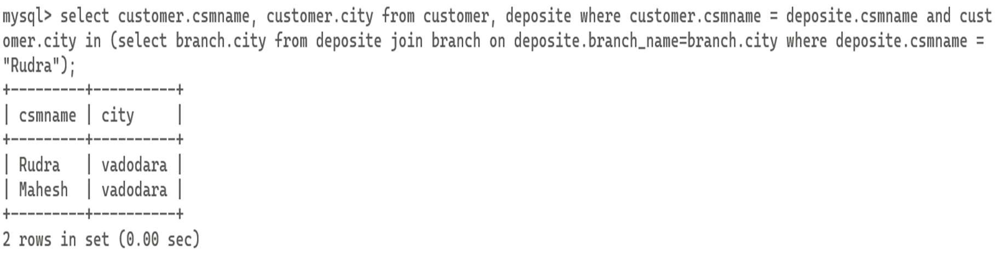

1. Give deposit details and loan details of customer in same city where pramod is living.

Output:

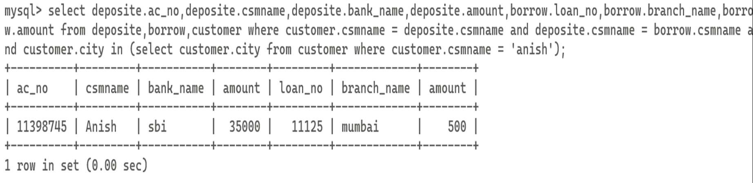

1. Create a query to display the employee numbers and last names of all employees who earn more than the average salary. Sort the results in ascending order of salary.

Output:

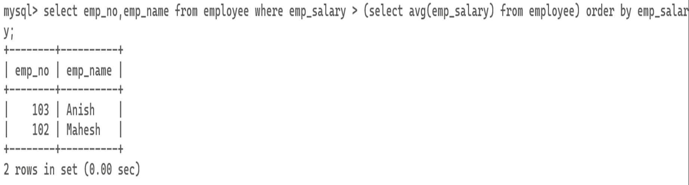

1. Give names of depositors having same living city as mr.anil and having deposit amount greater than 2000.

Output:

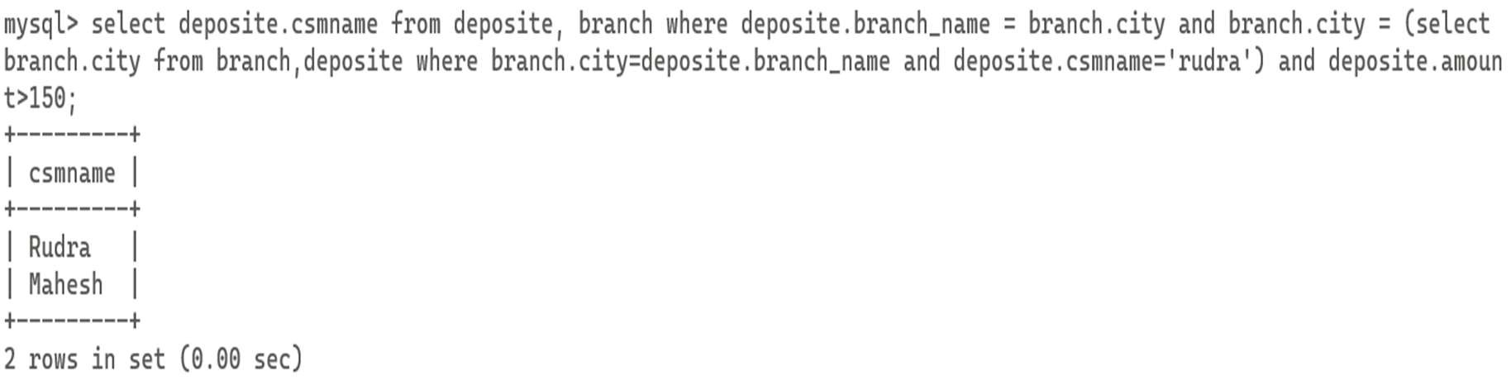

1. Display the last name and salary of every employee who reports to ford.

Output:

|  |
| --- |
|  |
|  |

1. Display the department number, name, and job for every employee in the Accounting department.

Output:

|  |
| --- |
|  |
|  |

1. List the name of branch having highest number of depositors.

Output:

|  |
| --- |
|  |
|  |

1. Give the name of cities where in which the maximum numbers of branches are located.

Output:

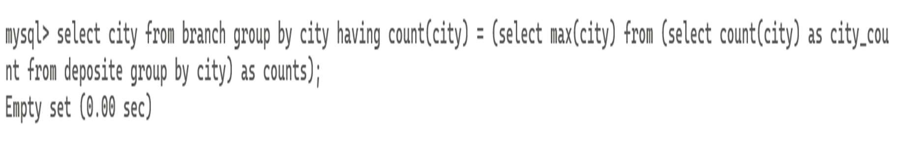

1. Give name of customers living in same city where maximum depositors are located.

Output:

|  |
| --- |
|  |
|  |